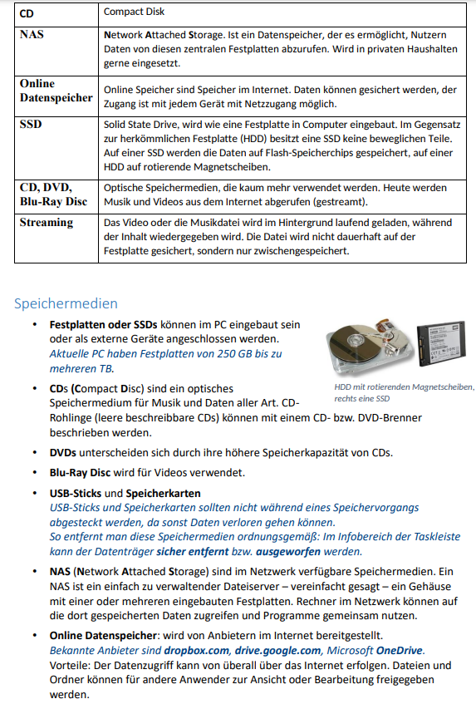

Speichermedien

I Drive

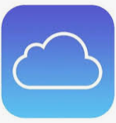

Dropbox Google Drive Microsoft One Drive

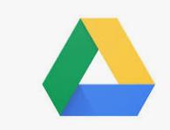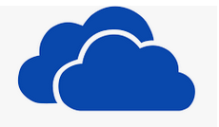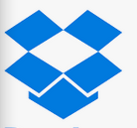

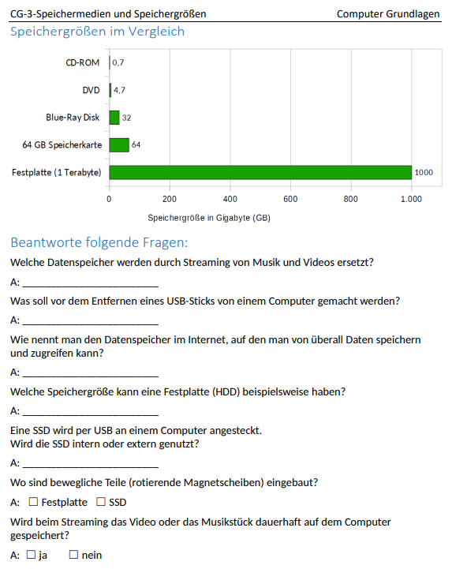

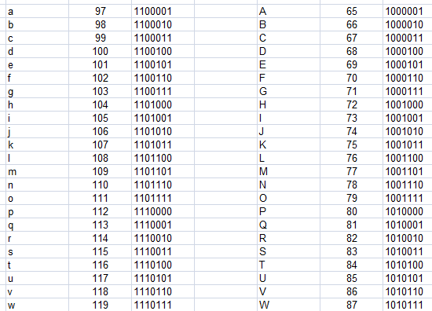

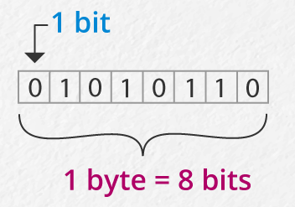

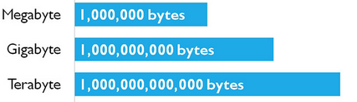

Dein Name in Bytes:_______________________________________________________________________________________________________________________________________________________________